**How to Build an AI Persona Chatbot**

AAA Incubator Resources - [Discord](http://discord.gg/dAa78Zj7yj) | [Resource Hub](https://www.liamottleyresources.com/) | [YouTube](https://www.youtube.com/@LiamOttley)

**Build on Stack AI:**

* **1. Sign up to Stack AI:** [Here](https://www.stack-ai.com/affiliate/liam-ottley-23)
* **2. Create a new project and drag in nodes:** 
  + Once a new project has been created, go to the LLMs on the left side of the screen and drag out an OpenAI node into your project.
  + Next drag in a Documents node from Data Loaders
  + Drag in a Basic node from Vector Stores
  + Drag in an Output node from Input/Output
* **3. Connect your nodes:** 
  + Connect Input to Basic
  + Input -> Open AI
  + Documents -> Basic
  + Output -> Basic
  + Basic -> Open AI
  + Open AI -> Output 2

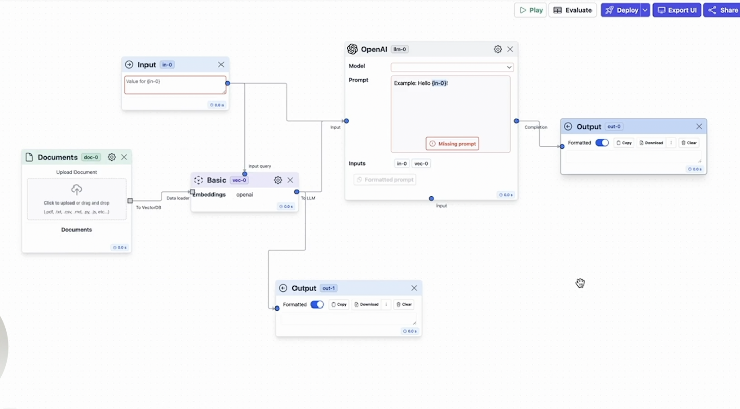

***What it should look like after connecting the nodes***

**Collect Information:**

* **1. Youtube Search:** Head over to youtube (or anywhere else you want to collect data from). In this case I’ll search for Ali Abdaal and head over to his channel.
* **2. Find videos you want to use as knowledge base:** 
  + For this example we’re only interested in Ali’s productivity videos and we'll navigate to his productivity playlist.
  + Open videos you want in new tabs (CTRL/CMND + Click to open link in new tab)
* **3. Generate Transcripts:**
  + Open a youtube transcript generator in a new tab. I like to use <https://youtubetranscript.com/>
  + Paste in the youtube link
  + Once the transcript has been generated you can copy the whole thing by clicking the ‘Copy entire transcript’ button on the bottom left corner.
  + Create a new TextEdit document and paste in the transcript. (Notepad for Windows users)
  + Save document with the name of the video
  + Repeat for the rest of the videos

**Back to Stack AI:**

* **1. Upload documents:** 
  + Head back over to Stack AI.
  + Click on the ‘Upload documents’ button in the documents node.
  + Select your TextEdit documents (Notepad for Windows)
  + Press Open
* **2. Selecting our Model:**
  + Toggle the ‘Model’ drop down menu on the Open AI node and select ‘gpt-3.5-turbo-16k’
* **3. Getting our prompt:**
  + Use the following prompt. You can use ChatGPT to ask it to change the prompt to match the person you want:
    - [***GET PROMPT HERE***](https://docs.google.com/document/d/1gNw9od0eW5dLD_SaekBJUU_ofw9vXYmqvtPptZww0D8/edit)
* **4. Paste Prompt:**
  + Paste Prompt into the ‘System’ textbox in the Open AI node
  + Paste this in the ‘Prompt’ textbox:

Context:

-----------

{vec-0}

-----------

Q: {in-0}

A:

* **5. Change Chunk Settings:**
  + Click on the settings Icon on the Documents node
  + Change Chunk Overlap to 150
  + Change Chunk Length to 900
* **6. Vector Store Settings:**
  + Click on the settings Icon on the Basic node
  + Change Result Length to 5000
* **7. Test Chatbot:** Congrats so far! Now we’re ready to start testing out this chatbot.
  + Type a question into the Input node
  + Press play on the top right of workspace
  + A response should be generated in the Output node
* **8. Check Memory is Switched On:**
  + Click on the settings Icon on the Open AI node
  + Switch Memory on if it isn’t already
  + Change memory type to ‘SlidingWindow’ in dropdown menu
  + Change Window Size to 6-7
* **9. Deploy:**
  + Click on ‘Deploy’ on the top of screen
  + Head over to the ‘Deployments’ tab
  + Select your project from the drop down menu
  + Click ‘JavaScript’

**Botpress:**

* **1. Sign Up to Botpress:** 
  + Keep your Stack AI tab open and create a new tab to sign in to Botpress
  + Sign Up: [Here](https://bit.ly/liam_botpress_signup)
* **2. Create New Chatbot:**
  + Click on ‘Create Chatbot’ on the left of the screen
  + Download Template: [***TEMPLATE AVAILABLE HERE***](https://drive.google.com/file/d/1s34TBfbddSKQ9DTSExW_peYUQgVG5uia/view)
  + Click on ‘Start from Template’
  + Click on ‘Basic (empty)’
* **3. Import Template:**
  + Click Botpress logo dropdown menu in top left
  + Go to import / Export and select Import from file
  + Select the template from your computer and import it into your project
  + You should see three nodes on screen

**Connecting Stack AI to Botpress:**

* **1. Link URL:**
  + Head back over to your Stack AI tab
  + Copy the URL down to the last quotation
  + Head back to botpress
  + Click on ‘Execute Code’ on the ‘FirstMessage’ node
  + Click on the edit box under ‘code’ on the right side of the screen and it should open the text editor.
  + Replace the endpoint with your url
* **2. Link API Key:**
  + Head back over to your Stack AI tab
  + Click on ‘Show Token’ on top right of the textbox
  + Your API Key should appear after ‘bearer’
  + Copy it
  + Head back to Botpress
  + After ‘Bearer’ in Botpress replace the ‘XXXXXXXXX’ with your API Key
* **3. Repeat with MainLoop:**
  + Copy Endpoint URL
  + Exit out of the editor into your main workspace
  + Press ‘Execute Code’ in ‘MainLoop’ node
  + Open Code Editor again
  + Replace Endpoint
  + Head back to Stack AI and copy API key again
  + Paste API key into Botpress after ‘Bearer’
* **4. Test it out:**
  + Drag up ‘Test your Chatbot’ from bottom right of screen.
  + Press the refresh button.
  + Start chatting

*NOTE: Your endpoint should be red and have quotations on either side!*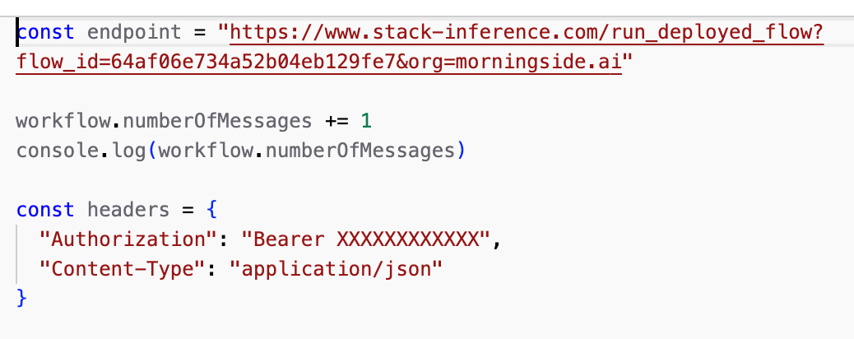

**Chat to Your Bot Outside of Botpress:**

* **1. Deploy onto a URL:**
  + Click Publish in the top right
  + Once published, head back to your Botpress Dashboard
  + Select your chatbot from the left
  + Press the ‘integrations’ tab from the top of the screen
  + Select ‘Webchat’ (If you can’t see it you need to click on ‘Browse in Hub’ and select it from there.)
  + Fill out information
  + Turn on the ‘Enable Integration’ switch
  + Click on ‘Pre-configured’ and copy Shareable URL
  + Paste into a new tab and start chatting!
* **2. Integrate with Whatsapp:**
  + Tutorial available [here](https://www.youtube.com/watch?v=LQd1iGJLj58&ab_channel=Botpress)